

**CAR FERRY**

**CROSSING**

**AHEAD**

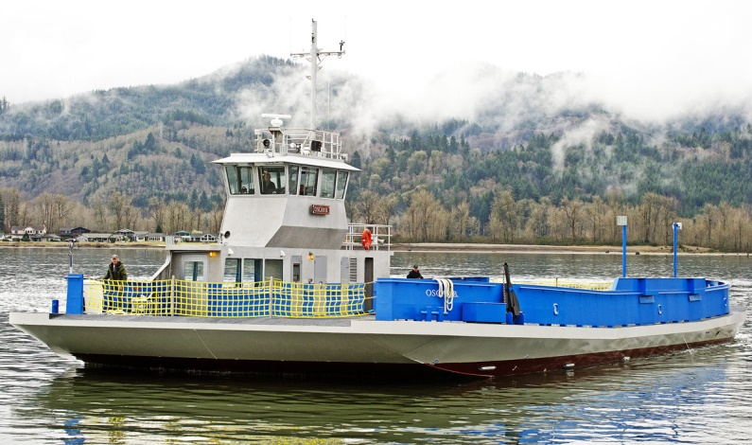

Please Join Us

All Interested People & Stakeholders

**Learn & Ask Session**

**Tuesday, September 22, 2016**

**Car Ferry Feasibility Study for Lake Sakakawea**

11:00 AM Red Hall, 315 Second Street SE, **Parshall**, ND

4:30 PM Twin Buttes Community Center, **Twin Buttes**, ND

**Presentors:** Bob Youness, Ulteig, Feasibility Study Engineer

Shirley Brentrup, Executive Director, Rural Economic Area Partnership Investment Fund

Ron Hall, Project Manager for the MHA Nation Transportation Planning Grant

For a copy of the study go to

[**http://reapmatters.org/projects/**](http://reapmatters.org/projects/)