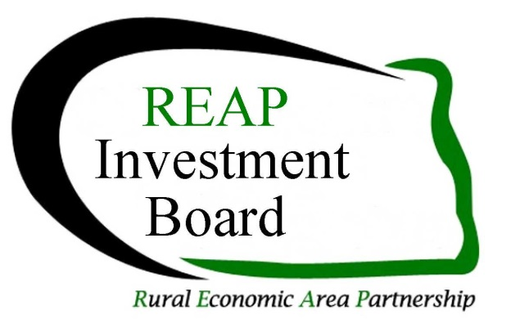

## REAP Revolving Loan Fund

## Guidelines & Procedures

Updated June 2018

Includes the Small City Loan Fund - Page 5

**Find the application, a sample application and these guidelines at the REAP Investment Fund website REAPMatters.org/funding**

**The REAP RLF is a “gap” lending program and is not designed to displace a commercial lender’s rate and term. The fund is designed to fill the gap when equity and commercial lending are unable to complete the loan package. The RLF will play a part in your project only when it can be shown that commercial lending cannot do the entire loan or the RLF’s rate and terms are necessary to achieve positive cash flow. The RLF is targeted to job creation or retention. This fund is limited to businesses of under 50 employees and under $1 million in revenues.**

1. **General Fund Information**
2. **Loans are made to businesses in the REAP Zone Counties (see map, Item 9)**
3. **Loans are from $10,000 to $50,000 but cannot exceed 50% of the total funding required**
4. **Interest rates will be no more than the US Prime Rate plus 1%**
5. **The term of the loan will be no more than:**

**Real Estate 15 Years**

**Equipment 5 to 7 Years**

**Working Capital 1 to three years**

1. **Applications must have a conditional letter of commitment from other sources of funds**
2. **Loan funds are secured by collateral and personal guarantees from the applicant, partners and majority stockholders having a 20% or greater ownership share in the business**
3. **Applications have a loan origination fee of $200 that will accompany the application submission of which half will be refunded if the application is denied**
4. **The successful borrower will be required to maintain hazard insurance on secured assets and in some cases, credit life or key man insurance with the RLF as loss payee (See also Item 6.b.)**
5. **Payments are to be made electronically and this is to be set up prior to receiving funds**
6. **Late fees are assessed at a rate of $15 per month**
7. **Eligibility & Collateral**

**a) Loans are made to businesses of less than 50 employees and under $1 million in revenues, not individuals, with primary sector businesses having preference**

1. **Primary sector business is defined as an individual, partnership, or association, which through the employment of knowledge or labor adds value to a product, process, or export service that results in the creation of new wealth. The term includes tourism, technology and export services but does not include production agriculture.**
2. **The $25,000 RLF may be loaned to a local development organization (local development corporation, job development authority, etc.) for a micro-loan program provided the local development organization shows their ability to repay the loan and has adopted policies and procedures for the loan program**
3. **Adequate collateral will be required to protect the interest of the RLF. The collateral must be of such a nature that repayment of a loan is reasonably assured. Formal appraisals may be required to value assets pledged as collateral.**

**Examples of acceptable collateral may include:**

**Accounts receivable and inventory for short-term loans**

**Machinery and equipment that has a developed market**

**Securities issued by the Federal Government or its agencies**

**Letter of credit from an acceptable financial institution**

**Real estate or non-business assets pledged as collateral**

1. **The RLF will consider deferment of principal payments for up to one year on loans over three years in length, with the balance amortized over the remaining life of the loan provided the project can demonstrate the deferral is merited and is imperative to the project’s ability to succeed.**
2. **Uses of the Funds**

**a) The RLF may be used to provide permanent financing for building construction or renovation, infrastructure (such as water, sewer, streets, etc.) real estate, machinery and equipment, and working capital**

1. **The RLF cannot be used to refinance existing debt**
2. **The RLF cannot be used to finance production agriculture, illegal activities, lending and investment institutions and insurance companies, golf courses, race tracks or gambling facilities**
3. **The RLF cannot be used for environmental reviews. Costs associated with completion of an environmental review will be the responsibility of the borrower**
4. **Application Procedures**
   1. **Requests for funding consist of:**

**Application – Request for Financial Assistance**

**General Business Plan or Project Description**

**Loan Processor’s assessment of the project (using criteria in 4.b)**

A minimum of a three year profit & loss projection

Personal Financial Statements for the principals

Three years tax returns for principals owning over 20% and the business

**A $200 check for the loan origination fee made out to the**

**REAP Investment Fund, Inc.**

**Documentation of commitment from other sources (letters or email confirmations)**

* 1. **Loan Processor: Applicants are encouraged to use their local economic development organization, Regional Council or the regional Small Business Development Center (SBDC) as their loan processor (See item c in this section). The lead bank may also be the loan processor as they have already considered lending criteria and requested financial documents. If the loan processor charges a fee, they should provide a good faith estimate to the borrower at the time of inquiry.**

**The loan processor could help with the application, assembling attachments and reviewing the application for eligibility and completeness. The loan processor provides an assessment of the project using the following lending criteria:**

* + 1. **Identification of the loan processor’s name, organization and contact information including their email address**
    2. **Detail the number of jobs created or retained and whether they are part-time, seasonal, or full time and the cost per job**
    3. **Job quality including wage rates, benefit packages offered, potential for longevity in employment, working environment and ability to advance the business**
    4. **Impact on the area economy & environment including whether jobs in other businesses in the local area or region could be at risk due to this project**
    5. **Leveraging of all funds, public & private**
    6. **Financial strength of the business or the borrower(s)**
    7. **Likelihood of business success and repayment of the loan**
    8. **Need and appropriateness of RLF funds and terms requested**
    9. **Management strength, expertise, and past performance of the borrower, business or staff**
    10. **Evidence of marketing or description of marketing plan**

**Note no single criterion will necessarily be decisive**

* 1. **The loan processors shouldn’t be the same person or organization involved in the actual preparation of the business plan or the pro-forma financial statements. Since financial projections are critical to the project and to the funding approval process, applicants are encouraged to use qualified accountants to prepare their financial statements. If the SBDC is assisting in the preparation of the financial statements, they cannot be the loan processor.**

1. **Application Submission to the REAP Investment Board**
   1. **Completed applications along with the servicing fee of $200 are to be submitted to the**

**REAP Investment Fund, Inc., 635 Oak Street, Dickinson, ND 58601. However, electronic submissions as an Adobe PDF are preferred. Applications may be electronically signed by the applicant and emailed to** [brentrup@ndsupernet.com](mailto:brentrup@ndsupernet.com). **Staff will review the application for completeness and direct it to the next REAP Investment Board Agenda.**

* 1. **The staff will notify the loan processor and the applicant of the time and place for their loan to be reviewed. The lead bank for the loan is encouraged to attend even if they aren’t the loan processor**
  2. **The loan is reviewed by the REAP Investment Board which usually meets by conference call the fourth Wednesday of odd numbered months. A board member listing is available at the REAP Investment Fund website.**
  3. **The staff will notify the loan processor and/or the applicant of the funding decision including the term and interest rate plus any loan requirements. In some cases, applicants cannot purchase or commit to purchasing materials, supplies, equipment, inventory, real estate or any other item related to the project before a specified date. Failure to adhere to this requirement may disallow the use of RLF monies in a project.**
  4. **The staff will prepare the closing documents**
  5. **The staff will disperse funds to the borrower upon:** 
     1. **Completion of the loan closing documents and compliance of any covenants in the closing documents**
     2. **Evidence that all funding has been committed**
     3. **Personal guarantees and collateral documents are completed**
     4. **Evidence that all loan conditions have been met**
     5. **Electronic payment arrangements have been completed**
     6. **Documentation of expenditures or commitment of funds for the approved purposes. Documentation may include invoices, purchase orders, bills of sale, deeds, receipts or other evidence.**

1. **Borrower Obligations and Loan Origination & Monitoring** 
   1. **The staff collects payments, remits to the RLF accounts, and prepares necessary progress reports and provides financial reporting to the REAP Investment Board. The staff also participates in USDA Rural Development reviews of the RLF program**
   2. **The Borrower is required to submit the following at least annually to the staff:**
      1. **A year-end balance sheet**
      2. **Proof of insurance as outlined in the closing documents**
      3. **Proof of paid property taxes If real estate is used as collateral**
      4. **An annual income and expense statement**
      5. **A few short paragraphs on milestones reached as outlined in the application process (jobs created, new customers, construction completed, etc.)**
      6. **More frequent financial reporting may be required according to loan conditions and the current status of loan performance**
      7. **Participate in annual site visits**
2. **Non Compliance by the Borrower**
   1. **Specific sanctions will be enforced for noncompliance with loan conditions or nonperformance. Nonperformance and/or noncompliance by the project will result in a freeze of any unused loan funds and denial of access to any additional funding through the REAP Investment Board and the establishment of a specific schedule to bring the project into compliance with the original terms and conditions of the loan agreement; recognition of the original loan; the determination to call the loan or any other remedy provided by law.**
3. **RLF History**
   1. 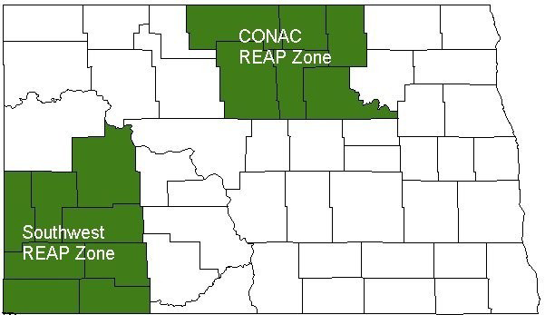**This fund was made available through the funds and efforts of USDA Rural Development and the Department of Housing and Urban Development and is administered by the members of the two North Dakota REAP Zones and the REAP Investment Fund, Inc.**
4. **North Dakota REAP Zone Map & Counties**

**Center of North America Coalition: McHenry, Bottineau, Rolette, Towner, Pierce, and Benson including the area of the Turtle Mountain Band of Chippewa and the Spirit Lake Reservation located in this area. Southwest REAP Zone: Dunn, Stark, Hettinger, Adams, Bowman, Slope, Golden Valley, and Billings, the Dunn County area on the Fort Berthold Reservation**

**REAP Guidelines for Small City RLF Program**

The RLF is targeted to job creation or retention within the boundaries of the CONAC and SW REAP Zones. Eligible projects can include community facilities but only those that demonstrate a positive impact on the local economy and don’t compete with existing retail operations in the area. It is meant to leverage other funds, if possible, and as such requires participation by other lenders or other programs such as city, local, state or federal programs.

**What kinds of funding are available?**

Low interest direct loans to small cities in the REAP Zones

**What are the funding priorities?**

Small communities with a population of 5,500 or less

Projects must have a direct relationship to the improvement of their business community

Funding is provided on a first come first serve basis

**What are the terms?**

Applications for this program are accepted year round

Loans between $10,000 and $50,000 but no more than 45% of the project costs (total project cost of at least $22,223)

Loan repayment terms may not exceed five years

Interest rates are set by REAP Investment Board

Once the loan is approved, the interest rate is fixed for the entire term of the loan

There are no pre-payment penalties

Projects are encouraged to be income producing

**Are there additional requirements?**

Applicants must have legal authority to borrow money, obtain security, repay loans, construct, operate, and maintain the proposed facilities

Projects must serve the business community or the workforce where they are/will be located

Project must demonstrate support from their business community

Environmental review must be completed/acceptable for building or construction projects

A 1% origination fee and if necessary the costs for an environmental review (REAP will not complete the environmental review for the applicant)

**How do we get started?**

Contact your local JDA or Development Corporation to discuss your specific project

* Complete a one page letter of proposal for your project to include:
  + City name and contact information
  + Description of the project and project partners if applicable
  + Short explanation of how this project benefits a business(es) or business community
  + An assurance those businesses meet the definition of small or emerging businesses (under 50 employees and $1 million in annual revenues)
  + Identify who will maintain the project in the future
  + Proposed costs, identify sources of funds and the project duration
* If the project is accepted, a loan package will be prepared for full review

**Small City RLF Program Continued:**

**Submit the letter to the REAP Investment Fund. See page 3, Item 5 for contact information.**

**Examples of possible projects**

Community commercial kitchens for preparation of foods for retail sales or wholesale

Downtown beautification projects or downtown public facility projects like public restrooms

Winter walking tunnels to connect businesses or community parking to businesses

Local transportation services or signage programs

Feasibility Studies or architectural designs for commercial buildings to be owned by the city

Renovations of city buildings for needed rentals such as meeting or training facilities

**Projects not considered:** Fire and ambulance; water and sewer; public works or safety projects; public facility improvements not directly linked to business needs.