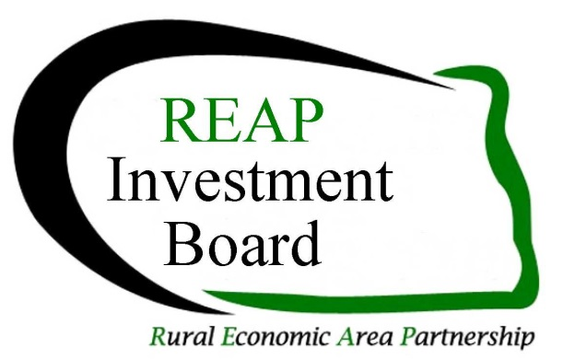

## REAP Revolving Loan Fund

## Guidelines & Procedures

Revised April 2015

**Find the application and these guidelines at the REAP Investment Fund website REAPMatters.org**

**The REAP RLF is a “gap” lending program and is not designed to displace a commercial lender’s rate and term. The fund is designed to fill the gap when equity and commercial lending are unable to complete the loan package. The RLF will play a part in your project only when it can be shown that commercial lending cannot do the entire loan or the RLF’s rate and terms are necessary to achieve positive cash flow. The RLF is targeted to job creation or retention. This fund is limited to businesses of under 50 employees and under $1 million in revenues.**

1. **General Fund Information**
2. **Loans are made to businesses in the REAP Zone Counties (see map, Item 9)**
3. **Loans are from $10,000 to $50,000 but cannot exceed 45% of the total funding required**
4. **Interest rates will be no more than the US Prime Rate plus 1%**
5. **The term of the loan will be no more than:**

**Real Estate 15 Years**

**Equipment 5 to 7 Years**

**Working Capital 1 to three years**

1. **Applications must have a conditional letter of commitment from other sources of funds**
2. **Loan funds are secured by collateral and personal guarantees from the applicant, partners and majority stockholders having a 20% or greater ownership share in the business**
3. **Applications have a loan origination fee of 1.5% of the loan amount with a minimum fee of $200. Of this amount, $200 will accompany the application submission of which half will be refunded if the application is denied**
4. **The successful borrower will be required to maintain hazard insurance on secured assets and in some cases, credit life or key man insurance with the RLF as loss payee**

**(See also Item 6.b.)**

1. **Payments are to be made electronically and this is to be set up prior to receiving funds**
2. **Late fees are assessed at a rate of $15 per month**
3. **Eligibility & Collateral**

**a) Loans are made to businesses of less than 50 employees and under $1 million in revenues , not individuals, with primary sector businesses having preference**

1. **Primary sector business is defined as an individual, partnership, or association, which through the employment of knowledge or labor adds value to a product, process, or export service that results in the creation of new wealth. The term includes tourism, technology and export services but does not include production agriculture.**
2. **The $25,000 RLF may be loaned to a local development organization (local development corporation, job development authority, etc.) for a micro-loan program provided the local development organization shows their ability to repay the loan and has adopted policies and procedures for the loan program**
3. **Adequate collateral will be required to protect the interest of the RLF. The collateral must be of such a nature that repayment of a loan is reasonably assured. Formal appraisals may be required to value assets pledged as collateral.**

**Examples of acceptable collateral may include:**

**Accounts receivable and inventory for short-term loans**

**Machinery and equipment that has a developed market**

**Securities issued by the Federal Government or its agencies**

**Letter of credit from an acceptable financial institution**

**Real estate or non-business assets pledged as collateral**

1. **The RLF will consider deferment of principal payments for up to one year on loans over three years in length, with the balance amortized over the remaining life of the loan provided the project can demonstrate the deferral is merited and is imperative to the project’s ability to succeed.**
2. **Uses of the Funds**

**a) The RLF may be used to provide permanent financing for building construction or renovation, infrastructure (such as water, sewer, streets, etc.) real estate, machinery and equipment, and working capital**

1. **The RLF cannot be used to refinance existing debt**
2. **The RLF cannot be used to finance production agriculture, illegal activities, lending and investment institutions and insurance companies, golf courses, race tracks or gambling facilities**
3. **The RLF cannot be used for environmental reviews. Costs associated with completion of an environmental review will be the responsibility of the borrower**
4. **Application Procedures**
   1. **Requests for funding consist of:**

**Application – Request for Financial Assistance**

**General Business Plan or Project Description**

**Loan Processor’s assessment of the project (using criteria in 4.b)**

A minimum of a three year profit & loss projection

Three years tax returns for principals owning over 20% and the business

**A $200 check for the minimum or partial loan origination fee made out to the**

**Roosevelt Custer Regional Council**

**Documentation of commitment from other sources (letters or email confirmations)**

* 1. **Loan Processor: Applicants are encouraged to use their local economic development organization, Regional Council or the regional Small Business Development Center (SBDC) as their loan processor (See item c in this section). The lead bank may also be the loan processor as they have already considered lending criteria and requested financial documents. If the loan processor charges a fee, they should provide a good faith estimate to the borrower at the time of inquiry. The loan processor would help with the application, assembling attachments and reviewing the application for eligibility and completeness. The loan processor provides an assessment of the project using the following lending criteria:**
     1. **Identification of the loan processor’s name, organization and contact information including their email address**
     2. **Detail the number of jobs created or retained and whether they are part-time, seasonal, or full time and the cost per job**
     3. **Job quality including wage rates, benefit packages offered, potential for longevity in employment, working environment and ability to advance the business**
     4. **Impact on the area economy & environment including whether jobs in other businesses in the local area or region could be at risk due to this project**
     5. **Leveraging of all funds, public & private**
     6. **Financial strength of the business or the borrower(s)**
     7. **Likelihood of business success and repayment of the loan**
     8. **Need and appropriateness of RLF funds and terms requested**
     9. **Management strength, expertise, and past performance of the borrower, business or staff**
     10. **Evidence of marketing or description of marketing plan**

**Note no single criterion will necessarily be decisive**

* 1. **The loan processors shouldn’t be the same person or organization involved in the actual preparation of the business plan or the pro-forma financial statements. Since financial projections are critical to the project and to the funding approval process, applicants are encouraged to use qualified accountants to prepare their financial statements. If the SBDC is assisting in the preparation of the financial statements, they cannot be the loan processor.**

1. **Application Submission to the REAP Investment Board**
   1. **Completed applications along with the partial servicing fee of $200 are to be submitted to the**

**REAP Investment Fund, Inc., c/o Roosevelt Custer Regional Council, 300 13 Ave. W., Dickinson, ND 58601. However, electronic submissions as an Adobe PDF are preferred. Applications may be electronically signed by the applicant and emailed to** [Schaff@rooseveltcuster.com](mailto:Schaff@rooseveltcuster.com). **The Roosevelt Custer Regional Council (RCRC) will review the application for completeness and direct it to the next REAP Investment Board Agenda.**

* 1. **The RCRC will notify the loan processor and the applicant of the time and place for their loan to be reviewed. The lead bank for the loan is encouraged to attend even if they aren’t the loan processor**
  2. **The loan is reviewed by the REAP Investment Board which usually meets by conference call the third Thursday of each month. A board member listing is available at the REAP Investment Fund website.**
  3. **The RCRC will notify the loan processor and/or the applicant of the funding decision including the term and interest rate plus any loan requirements. In some cases, applicants cannot purchase or commit to purchasing materials, supplies, equipment, inventory, real estate or any other item related to the project before a specified date. Failure to adhere to this requirement may disallow the use of RLF monies in a project.**
  4. **The RCRC will prepare the closing documents**
  5. **The RCRC will disperse funds to the borrower upon:** 
     1. **Completion of the loan closing documents and compliance of any covenants in the closing documents**
     2. **Evidence that all funding has been committed**
     3. **Personal guarantees and collateral documents are completed**
     4. **Evidence that all loan conditions have been met**
     5. **Electronic payment arrangements have been completed**
     6. **Documentation of expenditures or commitment of funds for the approved purposes. Documentation may include invoices, purchase orders, bills of sale, deeds, receipts or other evidence.**
     7. **Payment of any remaining loan servicing fees (1.5%) and closing fees (actual costs) will apply. These fees will be collected at the time of closing and may be paid from the proceeds of the loan.**

1. **Borrower Obligations and Loan Origination &Monitoring by the Roosevelt Custer Regional Council**
   1. **The RCRC collects payments, remits to the RLF accounts, and prepares necessary progress reports and their fiscal agent provides monthly financial reporting to the REAP Investment Board. The RCRC also participates in USDA Rural Development reviews of the RLF program**
   2. **The Borrower is required to submit the following at least annually to the RCRC:**
      1. **A yearend balance sheet**
      2. **Proof of insurance as outlined in the closing documents**
      3. **Proof of paid property taxes If real estate is used as collateral**
      4. **An annual income and expense statement**
      5. **A few short paragraphs on milestones reached as outlined in the application process (jobs created, new customers, construction completed, etc.)**
      6. **More frequent financial reporting may be required according to loan conditions and the current status of loan performance**
      7. **Participate in annual site visits**
2. **Non Compliance by the Borrower**
   1. **Specific sanctions will be enforced for noncompliance with loan conditions or nonperformance. Nonperformance and/or noncompliance by the project will result in a freeze of any unused loan funds and denial of access to any additional funding through the REAP Investment Board and the establishment of a specific schedule to bring the project into compliance with the original terms and conditions of the loan agreement; recognition of the original loan; the determination to call the loan or any other remedy provided by law.**
3. **RLF History**
   1. **This fund was made available through the funds and efforts of USDA Rural Development and the Department of Housing and Urban Development and is administered by the members of the two North Dakota REAP Zones and the REAP Investment Fund, Inc.**
4. 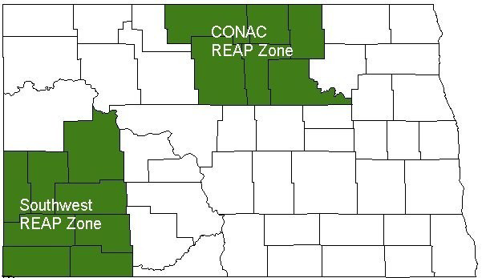**North Dakota REAP Zone Map & Counties**

**Center of North America Coalition: McHenry, Bottineau, Rolette, Towner, Pierce, and Benson including the area of the Turtle Mountain Band of Chippewa and the Spirit Lake Reservation located in this area.**

**Southwest REAP Zone: Dunn, Stark, Hettinger, Adams, Bowman, Slope, Golden Valley, and Billings, including that area in Dunn County on the Fort Berthold Reservation**